EMPLOYMENT

APPLICATION

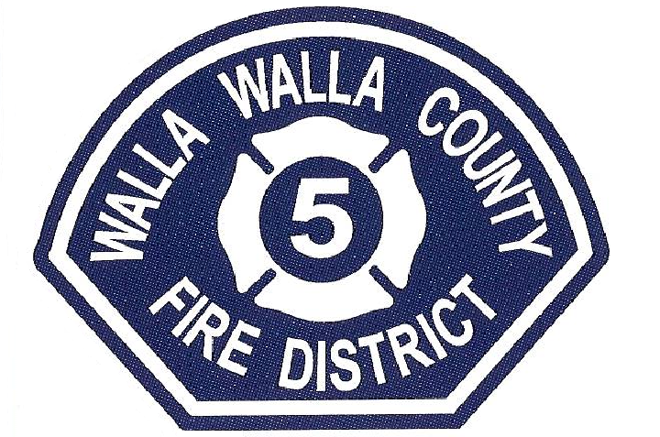

Application for Employment

We consider applicants for all positions without regard to race, color, religion, sex, national origin, age, marital or veteran status, qualified individual with disability status, or any other protected status. All applicants are required to complete an application for employment. Please inform the Administrative Staff if, as a result of a disability, you need accommodation to complete this application.

If you are applying to be a part time on-call Firefighter or volunteer or Resident Firefighter and do not have previous experience, WWCFD #5 will provide training through a training academy for wildland and structural firefighting. The District will also provide opportunities for Emergency Medical Technician training to firefighters involved with the District.

Along with calls for service, we provide fire prevention education with local elementary school students, pre-schools, and daycare centers. We also provide assistance and appearances at local community functions.

## Position(s) Applied For:

* Part time on-call Firefighter
* Part time on-call EMT
* Volunteer Resident Firefighter
* Part time on-call Logistics/Support Services
* Career EMT/Firefighter
* Career Paramedic/Firefighter

**Date of Application:** __________________________________

**Minimum requirements for becoming a Volunteer Firefighter include:**

• Complete an accurate application (incomplete applications will not be accepted)

• Must be 18 years of age at appointment and eligible to work in the United States

• Possess a High School Diploma or GED

• Have and maintain an insurable driving record with no more than two traffic violations

• Have a clear criminal history for crimes against people, drugs, and firearms, etc.

• Must be and maintain physical fitness for duty and be capable of performing any required firefighting, rescue, and emergency medical activities

• Successfully pass a Washington State Patrol background check

• Live within a reasonable response time to District boundaries and/or stations.

• Pass a physical agility test

## How Did You Learn About Us?

Newsletter ______ Friend ______ Website ______ Other ______

**GENERAL INFORMATION: (PLEASE PRINT)**

Name: _____________________________________________________________________________________

(First) (Last) (MI)

Mailing Address: ______________________________________________________________________________

(Street) (City/Town) (State) (Zip Code)

Telephone Number(s) Home: ______________________________ Cell: ____________________________

Email Address: ________________________________________________________________

Social Security Number: _______________________________________________________

Date of Birth: ______________________________________

Do you currently have a valid Washington State Driver License? Yes _____ No _____

If Yes: License Number________________________________

Do you currently have a valid commercial driver’s license? Yes_____ No_____

Have you been known by any other names in the past? Yes _____No_____. If yes please list below:

_______________________________________________________________________________

**EDUCATION INFORMATION**

School Names and Locations:

High School: _____________________________________________________________

Year’s completed_________ Graduated: Yes No GED: Yes No

*If currently in school, include in present term.

**Name & Location** **From - To**  **Field of Study Degree**

|  |  |  |  |
| --- | --- | --- | --- |
|  |  |  |  |
|  |  |  |  |
|  |  |  |  |

**EMPLOYMENT EXPERIENCE** (Attach resume’ if applicable)

Provide information on present and former employers beginning with the most recent. Include any job-related military service assignments and volunteer activities. You may exclude organizations which indicate race, color, religion, gender, national origin, disabled or other protected status.

Are you currently employed? Yes______ No______

May we contact your present employer? Yes______ No______

Employer: ________________________________ Phone Number: _________________

Job Title: ___________________________ Supervisor: ________________________________

From: _________ To:____________ Full Time or Part Time

Job Duties: __________________________________________________________________

Reason for leaving: ____________________________________________________________

Employer: ________________________________ Phone Number: _________________

Job Title: ___________________________ Supervisor: ________________________________

From: _________ To: ____________ Full Time or Part Time

Job Duties: __________________________________________________________________

Reason for leaving: ____________________________________________________________

Employer: ________________________________ Phone Number: _________________

Job Title: ___________________________ Supervisor: ________________________________

From: _________ To: ____________ Full Time or Part Time

Job Duties: __________________________________________________________________

Reason for leaving: ____________________________________________________________

Are you familiar with the job description and requirements of a Firefighter / EMT / Resident FF / Support Services?

Yes_____ No_____

Are you being recommended by a current member of this District, or have any relatives presently employed by this District?

Yes_______ No_______ If Yes, please list name(s): _____________________________

**Firefighting / EMT Experience**

Agency Name: _______________________________________ Phone Number: ____________________________

Training/Experience: ____________________________________________________________________________

Start Date: ___________________ End Date: _____________________ Paid or Volunteer (circle one)

Agency Name: _______________________________________ Phone Number: ____________________________

Training/Experience: ____________________________________________________________________________

Start Date: ___________________ End Date: _____________________ Paid or Volunteer (circle one)

* CPR/AED Card – Expires. ________________
* First Responder – Expires. ________________
* EMT-B – State: _________________ Expires. ______________
* EMT-A – State: _________________ Expires. _______________
* Paramedic – State: __________________ Expires. ________________

**Please attach a copy of your training certificates & Qualifications**

Describe any specialized training, apprenticeship, skills and extra-curricular activities, job related skills and qualifications acquired from employment or other experience. (May use additional paper or **attach resume’**):

________________________________________________________________________________________________________________________________

_______________________________________________________________________________________________________________________________

_____________________________________________________________________________________________________________________________

Have you ever had any job-related training in the United States military? Yes___ No___ If Yes, Branch- __________

Please describe:

________________________________________________________________________________________________________________________________

________________________________________________________________________________________________________________________________

Are you physically or otherwise able to perform the essential functions of the position for which you are applying, either with or without reasonable accommodation? Yes_______ No_______

**WAVIER AND AUTHORIZATION TO RELEASE INFORMATION**

**TO WHOM IT MAY CONCERN:**

*I authorize you to furnish Walla Walla County Fire Protection District 5 with any and all information that you have concerning me, my work record, my reputation, my medical records, and my military service records. I also authorize you to furnish criminal history record information (if any) to said fire district. Your reply will be used to assist this fire district in determining my qualifications and fitness for the position I am seeking with Walla Walla County Fire Protection District 5.*

*I authorize the District to obtain a driving record Abstract of Complete Driving Record.*

*I understand my rights under Title 5, United States Code, Section 552A, The Privacy Act of 1974, and waive those rights with the understanding that information furnished will be used by Walla Walla County Fire Protection District 5 in conjunction with employment procedures.*

*I hereby release you, your organization, and others, from any liability or damage which may result from furnishing the information requested.*

**_____________________________________________**

**APPLICANT SIGNATURE**

 **________________________**

**DATE**

SUBSCRIBED AND SWORN to before me this ______ day of _________________, 20_____.

                                                           Notary Signature: ____________________________________

                                                  Printed Name: _________________________________

Notary Public in and for the

                                                  State of Washington, residing

                                                  at __________________________________

**NOTE: A photocopy reproduction of this request shall be for all intents and purposes as valid as the original. You may retain this form in your files.**

**CONFIDENTIAL**

**DISCLOSURE REPORT**

If Walla Walla County Fire Protection District No. 5 decides to obtain a criminal background check, RCW 43.43.834(2) requires that Walla Walla County Fire Protection District No. 5 obtain the following information from an applicant if an employee in the position applied for may have unsupervised access to children under sixteen (16) years of age or developmentally disabled person or vulnerable adults during the course of employment.

**To comply with the statutory requirements, please provide the following information under oath:**

1. **Have you ever been convicted of any crime?** Yes No (circle)
2. **Have you had findings made against you in any civil adjudicative proceeding as defined in RCW 43.43.830?**

Yes No (circle)

1. **Have you had both a conviction under 1 above and findings made against you under 2 above?**

Yes No (circle)

__________________ ________________________________________________________

Date Signature

**I certify that I have satisfactory evidence that _____________________________ is the person who appeared before me, and said person acknowledged that he/she signed this instrument and acknowledged it to be his/her free and voluntary act for the uses and purpose mention in the instrument.**

SUBSCRIBED AND SWORN to before me this ______ day of _________________, 20_____.

                                 Notary Signature: ____________________________________

                                                  Printed Name: _________________________________

Notary Public in and for the

                                                  State of Washington, residing

                                                  at __________________________________

                                                  My commission expires: __________

*NOTE: A PHOTOCOPY REPRODUCTION OF THIS REQUEST SHALL BE FOR ALL INTENTS AND PURPOSES AS VALID AS THE ORIGINAL.*

**If you are offered a position as a paid employee or volunteer with the District, the District may under RCW 43.43.832 and RCW 43.43.834 submit an inquiry to the Washington State Patrol to conduct a records check to verify the answers provided above. You will be notified within ten (10) days after a response is received from the Washington State Patrol of the nature of the response and be provided a copy of the response. The District will use this record only to make the initial employment decision.**

**Return Completed Application to: Walla Walla County Fire District 5 460 W. Humorist Rd. Burbank, WA 99323**

**Minimum Physical Agility Requirements**

**Firefighter/EMS**

Must complete agility course within (5) minutes

Career candidates must complete course within (4) minutes

All participants will be required to wear a Turn-Out Coat, Helmet, Gloves and SCBA (w/o mask) during the Physical Agility Evaluation.

1. Shoulder carry 50 ft. bundle of 2 ½ hose up a flight of stairs, place the bundle in designated location,

1. Lift a 50 ft. roll of 2 ½ hose from the ground with rope from a second story window, hand over hand, pull through window, place hose bundle out of the window and lower to ground hand over hand without slipping and place hose bundle on floor.
2. lift the 50 ft. hose bundle again to shoulder and come down a separate flight of stairs to a designated location.
3. Pull a 50 ft. bundle of 2 ½ hose from the ground with rope, hand over hand, to a fixed anchor 2 ½ stories above the ground and then lower to ground without letting the rope slide through hands. Repeat. (EMS Only 1 sequence)
4. Strike the tire 10 times using an 8lb. sledge hammer.
5. Pick up two pails weighing 25 lbs apiece and walk 100 ft. set the pails in a designated location.
6. Pull a weighted sled at Level #2, 50 feet with rope provided, stop, and then push the weighted sled back to its starting position. (Time Stops).
7. Climb the 75 foot Ladder at a 35 degree angle and touch the top rung. (This evolution is not timed, EMS is excluded from this).